**Manipur**

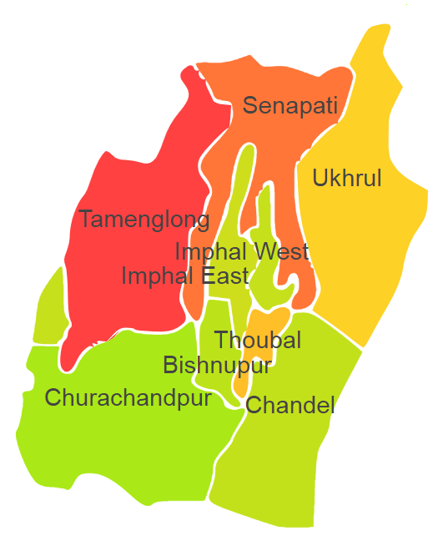

Manipur comprises of one Agro Ecological Region (AER) 17.

**Agro-Eco Region 17:** AER 17 in Manipur comprises of Bishnupur, Chandel, Churachandpur, Senapati, Tamenglong, Thoubal, Ukhrul, Imphal West and Imphal East districts North-eastern Hills (Purvachal) under Agro Ecological Sub Regions (AESR) 17.2.

**AESR 17.2:** The region is warm to hot perhumid ESR with medium to deep loamy Red and Yellow soils, low to medium AWC and LGP 300 days in a year.